Western Australian Certificate of Education
ATAR course examination, 2017

Question/Answer Booklet

12 PHYSICS
Name

Test 5 – Induced EMF

Student Number: In figures

Mark: $\frac{}{\text{55}}$
In words

Time allowed for this paper
Reading time before commencing work: five minutes
Working time for paper: sixty minutes

Materials required/recommended for this paper

To be provided by the supervisor
This Question/Answer Booklet
Formulae and Data Booklet

To be provided by the candidate
Standard items: pens, (blue/black preferred), pencils (including coloured), sharpener, correction fluid/tape, eraser, ruler, highlighters
Special items: non-programmable calculators satisfying the conditions set by the School Curriculum and Standards Authority for this course

Important note to candidates
No other items may be taken into the examination room. It is your responsibility to ensure that you do not have any unauthorised notes or other items of a non-personal nature in the examination room. If you have any unauthorised material with you, hand it to the supervisor before reading any further.

Structure of this paper

Section | Number of questions available | Number of questions to be answered | Suggested working time  (minutes) | Marks available | Percentage of exam
Section One:  Short Answers | - | - | - | - | -
Section Two:  Problem-solving | 9 | 9 | 60 | 55 | 100
Section Three:  Comprehension | - | - | - | - | -
 |  |  |  | Total | 100

Instructions to candidates

1. The rules for the conduct of examinations at Holy Cross College are detailed in the College Examination Policy. Sitting this examination implies that you agree to abide by these rules.

2. Write your answers in this Question/Answer Booklet.

3. Working or reasoning should be clearly shown when calculating or estimating answers.

4. You must be careful to confine your responses to the specific questions asked and to follow any instructions that are specific to a particular question.

5. Spare pages are included at the end of this booklet. They can be used for planning your
responses and/or as additional space if required to continue an answer.

• Planning: If you use the spare pages for planning, indicate this clearly at the top of the page.
• Continuing an answer: If you need to use the space to continue an answer, indicate in the original answer space where the answer is continued, i.e. give the page number. Fill in the number of the question(s) that you are continuing to answer at the top of the page.

6. Answers to questions involving calculations should be evaluated and given in decimal
form. It is suggested that you quote all answers to three significant figures, with the
exception of questions for which estimates are required. Despite an incorrect final result, credit may be obtained for method and working, providing these are clearly and legibly set out.

7. Questions containing the instruction "estimate" may give insufficient numerical data for their solution. Students should provide appropriate figures to enable an approximate solution to be obtained. Give final answers to a maximum of two significant figures and include appropriate units where applicable.

8. Note that when an answer is a vector quantity, it must be given with magnitude and direction.

9. In all calculations, units must be consistent throughout your working.
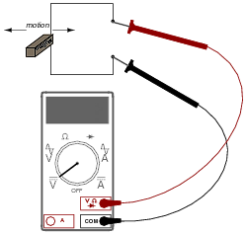
1. By moving a permanent magnet sideways perpendicularly past a wire, a voltage will be generated between the ends of that wire.

(a) Describe the factors that determine the polarity and magnitude of this voltage. [4 marks]

(b) In the diagram given, when moving the permanent magnet sideways to the left, the red probe attached to the positive jack of the voltmeter produces a positive reading.
Which pole of the magnet is closest to the wire? [1 mark]

2. In each of the diagrams below, clearly show the direction of the induced current through the resistor XY when the magnet moves relative to the coil as shown. [2marks]

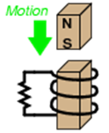  Y  X | 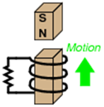  Y  X

3. Consider the coil of wire located the magnetic field shown.

(a) How many turns of wire must the coil have in order to induce a voltage of 10.5 volts when exposed to a magnetic flux decreasing at a rate of 7.50 x 10⁻³ Wbs^{–1}? [3 marks]
B out

(b) On the diagram above, clearly show the direction of the induced current in the loop. [1 mark]

4. Electromechanical watt-hour meters use an aluminium disk that is spun by an electric motor. To generate a constant “drag” on the disk necessary to limit its rotational speed, a strong magnet is placed in such a way that its lines of magnetic flux pass perpendicularly through the disk’s thickness.
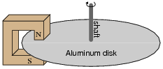

(a) Using the laws of induction, explain the phenomenon behind this magnetic “drag” mechanism. [5 marks]

(b) Explain how the permanent magnet assembly should be re-positioned so that it provides less drag on the disk for the same rotational speed. The poles of the magnet remain completely over the disk. [2 marks]

5. The diagram below shows a conducting bar PQ moving with constant speed, 2.00 ms^{–1}, along two parallel conducting rails 3.00 m apart. The ends of the bar touch the rails. The rails are connected by a 10.0 Ω resistor, as shown. The resistance of the bar and rails is negligible.

There is a uniform magnetic field of magnitude 0.500 T perpendicular to the bar and the rails. This field is directed into the page.
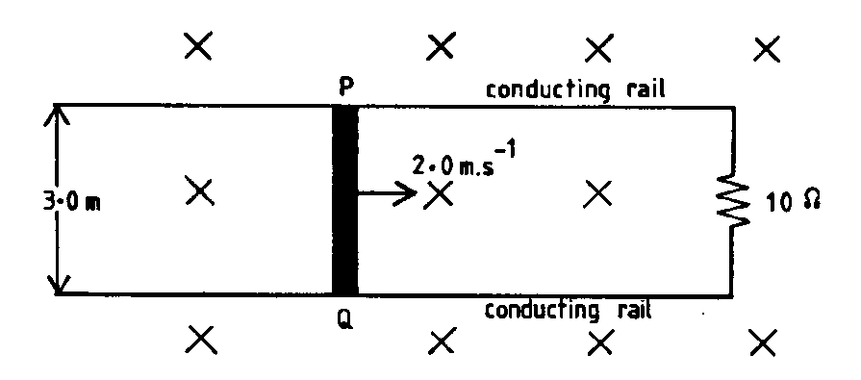

(a) What is the magnitude of the EMF induced in the bar? Show your working. [2 marks]

(b) What is the magnitude of the force required to keep the bar moving? Show your working. [2 marks]

(c) The rails are frictionless and there is good electrical contact between the bar and the rails. Why is it necessary to apply a force to keep the bar moving at a constant speed?
[2 marks]

6. Two coils A and B are placed closed together, as shown below. P and Q are soft iron cores.

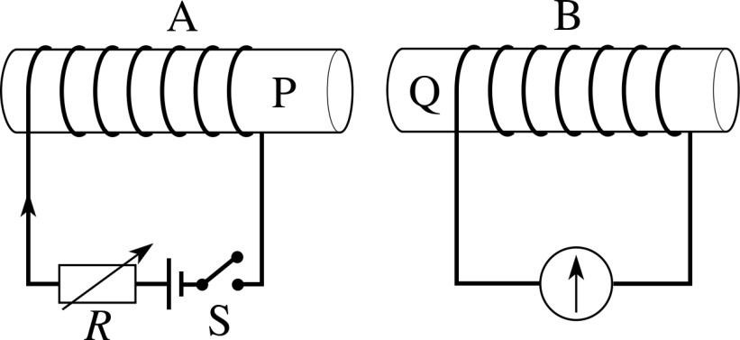

(a) Show the direction of the current induced in coil B when the switch in coil A is closed.
[1 mark]

(b) The graph below shows how the magnet field strength changes in coil A when the switch closes.
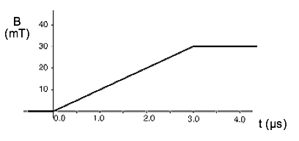

Assume that all of the magnetic flux from coil A passes through coil B which has an area of 5.00 cm².

(i) Calculate the EMF induced in coil B. [5 marks]

(ii) On the axes below draw the graph of the EMF calculated in (i). [3 marks]
[t = 0 s when the switch is closed.]

7. (a) A generator has a rectangular coil of side 15.0 cm by 12.0 cm that lies perpendicular to a magnetic field of flux density 4.00 T. What is the magnetic flux passing though the coil? [2 marks]

(b) The coil, consisting of 20 turns of wire, is rotated and generates a peak EMF of 63.5 V. Calculate the frequency with which it is being rotated. [2 marks]

(c) The coil of the above generator is shown below. In Figure 7A, the coil is connected to slip rings. In Figure 7B, the coil is connected to a split commutator.

current  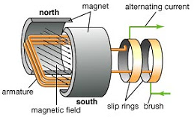  Fig 7A | current  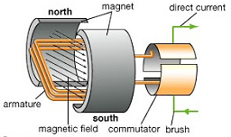  Fig 7B

(i) On Figure 7A, clearly show the direction of rotation of the coil that induces the direction of the current shown on the diagram. [1 mark]

(ii) On the axes below, draw the graph of the EMF induced by during one rotation of each of the generators above. (Assume that time t = 0 s when the coil is located in the position shown in Figure 7A and in Figure 7B.)

Also, indicate clearly on the graph the time when the plane of the coil is parallel with the magnetic field. [5 marks]

Fig 7A | Fig 7B

8. The following transformer is required to operate a 15.0 V AC device, as shown, in WA.

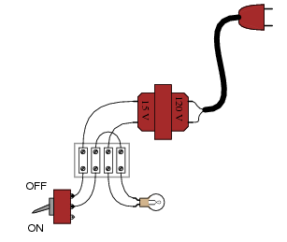

(a) Determine the turns ratio Ns : Np for the transformer. [2 marks]

(b) Some transformers can be up to 98% efficient. Describe 2 methods used in the construction of transformers to produce this efficiency. [2 marks]

9. Suppose a power system were delivering AC power to a resistive load drawing 150 amps.

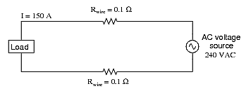

(a) Calculate the load voltage and the load power dissipation. [3 marks]

(b) Now, suppose we were to use a pair of perfectly efficient 10:1 transformers to step the voltage up for transmission, and back down again for use at the load.

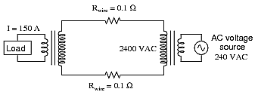

Calculate the load voltage, load power and the power loss of this system. [5 marks]

